DATA HANDLING AND VISUALIZATION ACTIVITIES
Question 1: Household Budget Pie Chart
Draw a pie chart representation of the distribution of spending in a household budget and determine the weighted average category of spending based on the following distribution:
Category | Percentage
Housing | 40%
Transportation | 20%
Food | 30%
Entertainment | 10%
Verification: 40% + 20% + 30% + 10% = 100% (valid pie chart).
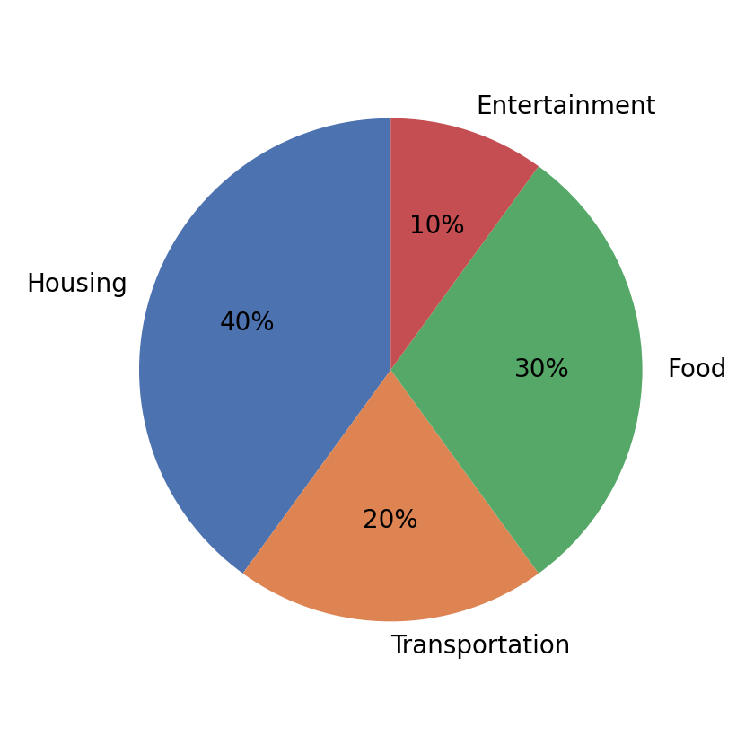
Interpretation: Housing accounts for the largest share of household spending among the four categories.
A weighted average spending category cannot be calculated from percentages alone because the spending categories are categorical variables and no numerical spending amounts or category values are provided. Housing is the largest spending category at 40%.
Question 2: Student Grades Bar Chart and Class Average
Grade intervals: A: 90–100, B: 80–89, C: 70–79, D: 60–69, E: Below 60. In a class of 30 students, describe the above details with a bar chart. What was the average score of the class on this test?
The original question does not provide the number of students in each grade category or individual student scores. To fulfil the visualization requirement, an illustrative frequency distribution is assumed below.
Grade | Score Range | Assumed Number of Students
A | 90–100 | 5
B | 80–89 | 8
C | 70–79 | 9
D | 60–69 | 5
E | Below 60 | 3
Verification: 5 + 8 + 9 + 5 + 3 = 30 students.
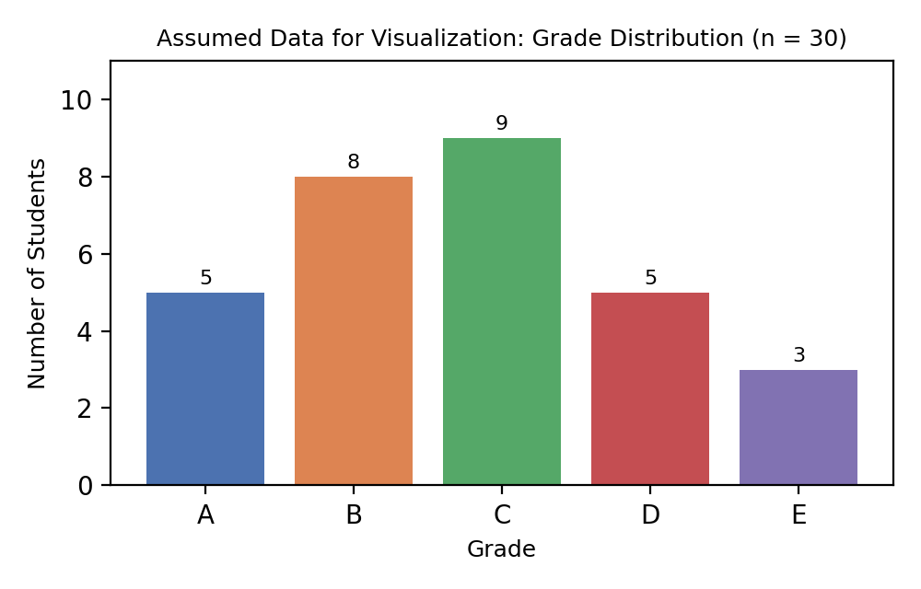
Interpretation: Under the assumed distribution, Grade C has the highest number of students.
Estimated class average calculation using representative grade scores (A = 95, B = 85, C = 75, D = 65, E = 55):
Estimated Average = (5×95 + 8×85 + 9×75 + 5×65 + 3×55) / 30 = 2320 / 30 = 77.33 marks.
Since the original question does not provide grade frequencies or individual scores, the bar chart uses assumed frequencies totaling 30 students, and 77.33 marks is an estimated average based on representative grade scores.
Question 3: Favourite Fruit Bar Chart
If the survey participants were asked to choose only one fruit as their favourite, which fruit was the most preferred among them, and find the low preferred fruit with the bar chart.
The original fruit preference data is not provided. To fulfil the visualization requirement, an illustrative dataset is assumed below.
Fruit | Assumed Number of Participants
Apple | 12
Banana | 8
Orange | 10
Mango | 15
Grapes | 5
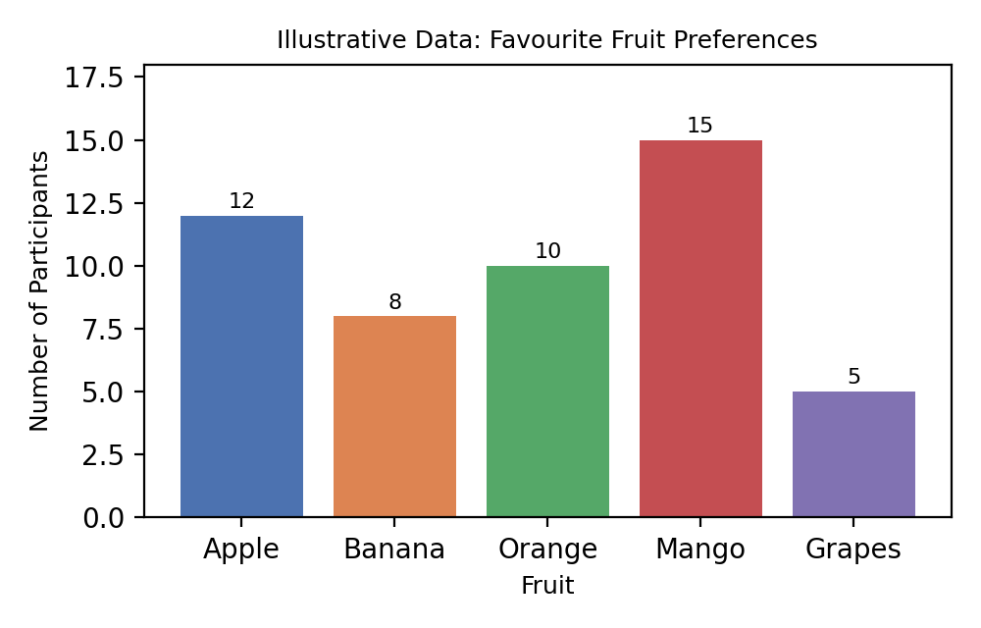
Interpretation: Under the assumed data, Mango is the most preferred fruit and Grapes is the least preferred fruit.
Since the original fruit preference data is not provided, illustrative data is used only to demonstrate the required bar chart and analysis. Mango is the most preferred fruit with 15 participants, and Grapes is the least preferred fruit with 5 participants.
Question 4: Employees in Marketing Department
If there are 200 employees in total, how many employees are likely to work in the Marketing department based on the pie chart?
The Marketing percentage from the original referenced pie chart is not provided. To fulfil the visualization requirement, an illustrative department distribution totaling 100% is assumed below.
Department | Assumed Percentage
HR | 20%
IT | 30%
Finance | 25%
Marketing | 25%
Verification: 20% + 30% + 25% + 25% = 100% (valid pie chart).
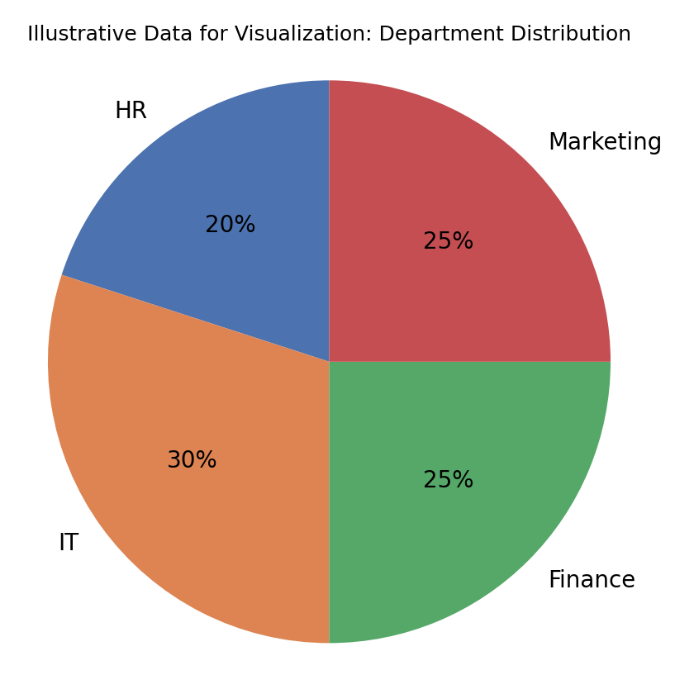
Interpretation: Under the assumed distribution, IT has the largest department share and Marketing accounts for 25%.
Required formula: Number of Marketing Employees = (Marketing Percentage / 100) × 200.
Marketing Employees = (25 / 100) × 200 = 50 employees.
Since the Marketing percentage from the original referenced pie chart is not provided, an illustrative department distribution is used. Based on the assumed Marketing share of 25%, 50 out of 200 employees work in Marketing.
Question 5: Weekend Activities Pie Chart
A company conducted a survey to find out how its employees spend their free time during the weekends. The results were represented in the form of a pie chart as follows:
Activity | Reported Percentage
Video Games | 20%
Reading | 35%
Cooking | 20%
Painting | 10%
Music Listening | 25%
Data verification: 20% + 35% + 20% + 10% + 25% = 110%. The provided percentages total 110%, so the data is inconsistent for a valid pie chart and should be corrected before constructing the chart.
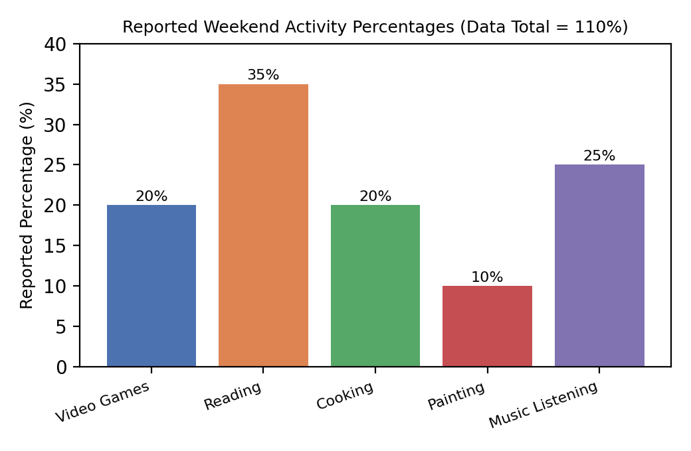
Interpretation: Among the reported values, Reading has the highest percentage.
Reading is the most common weekend activity because it has the highest reported percentage, 35%.

